Overview of Project Organizational Structures
Understanding the type of organizational structure is crucial for effective project management. The primary structures include: (Bài đọc tham khảo)
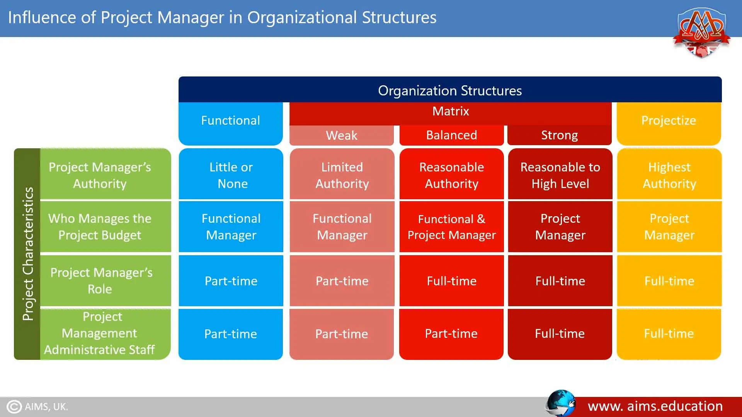

1. Functional Organization
- Structure: Divided into departments based on functions (e.g., marketing, finance)
- Project Manager's Authority: Limited; often acts as a coordinator or expeditor
- Resource Allocation: Controlled by functional managers
- Advantages: Clear hierarchy, specialization
- Disadvantages: Limited communication across departments, slow decision-making

2. Matrix Organization
- Structure: Combines functional and projectized structures
- Types:
  - Weak Matrix: Functional managers hold more authority
  - Balanced Matrix: Equal authority between project and functional managers
  - Strong Matrix: Project managers have more authority
- Advantages: Efficient resource use, flexibility
- Disadvantages: Dual authority can lead to confusion

3. Projectized Organization
- Structure: Teams are organized around projects
- Project Manager's Authority: High; full-time role with significant control
- Resource Allocation: Project managers control resources
- Advantages: High project visibility, quick decision-making
- Disadvantages: Resource duplication, team members may lack a clear career path post-project

Analysis of Three Projects

Project 1: Development of a Mobile Banking Application
- Current Structure Balanced Matrix Project manager and functional managers share authority. Team members report to both managers.
- Recommended Structure: Strong Matrix
  - Justification Given the project's complexity and the need for swift decision-making, a strong matrix would empower the project manager to coordinate effectively across departments, ensuring timely delivery.

Project 2: Implementation of a New CRM System
- Current Structure Functional: Each department manages its part of the implementation.
- Recommended Structure Balanced Matrix
  - Justification: Transitioning to a balanced matrix would facilitate better coordination across departments, ensuring the CRM system meets the organization's holistic needs.

Project 3: Launch of a Marketing Campaign for a New Product
- Current Structure Projected: A dedicated team focuses solely on the campaign.
- Recommended Structure Projected
  - Justification: Maintaining a projectized structure allows for focused efforts, rapid decision-making, and flexibility, which are essential for a successful marketing campaign.

Analysis of External Projects

Project A: Construction of a High-Speed Rail Line
- *Observed Structure: Projected
- Dedicated teams oversee different segments of the project.
- *Assessment: Appropriate, as large infrastructure projects benefit from focused teams with clear authority.

Project B: Development of a National Health Information System
- *Observed Structure: Weak Matrix
- Functional departments lead with minimal project management oversight.
- *Assessment: Suboptimal; a balanced or strong matrix would enhance coordination and integration across departments, leading to a more cohesive system.

